WHITE-TAILED DEER
You have found a baby fawn by itself
How you handle this situation is crucial to the baby’s survival and your safety.
When born, fawns have limited scent on them. To ensure no predators find them, over the next 10 days the mother will feed them, then leaves…for up to 8-10 hours before the next feeding. She is not far away, within ear shot. She moves them short distances until they are strength enough to follow her. If she has twins, she will put them in separate locations, never together.
FIRST: Walk away and observe from a distance. Standing over a fawn increases their heart rate to a dangerous level. Do not talk to them. Do not touch them.
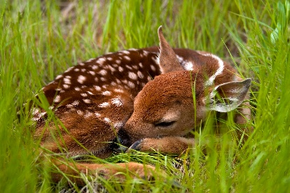
ALWAYS REMEMGER….TO THEM, YOU ARE A PREDATOR
What is the baby doing?
- Curled up like a kitten? Leave it alone. Mom is nearby.

ONLY INTERVENE IF THE BABY IS:
- Laying on its side? continuously crying? injured? bloody? flies buzzing around? – With gloves, a large towel and no talking….not one word put the baby in a large carrier. Cover its head. **If the baby is conscious, it more than likely will cry out when you pick it up. BE CAREFUL. If Mom or another female doe is nearby, they will respond… running. They use their hooves to fight off predators which can cut like a knife! Best to have another person stand guard who can wave their hands around and yell no mom in case this happens!!
- Call your nearest wildlife rehabilitator immediately.
- DO NOT FEED IT ANYTHING
- In their eyes, we are predators. Our voices will terrify them more than they already are. “It’s OK. I won’t hurt you. You’ll be OK” may be soothing to your pet, but not wildlife.

YOU HAVE FOUND AN INJURED ADULT DEER
Deer are prey animals, meaning larger predators/carnivores will attack them, their fawns or injured. They are genetically programmed to be on high alert at all times. Unfortunately, with deer, a condition known as Capture Myopathy prevents us helping adults even with minor injuries. When captured, their response is terror. They can literally die of fright, not to mention their size and their sharp hooves, which they will use to defend themselves.
SO OUR RULE OF THUMB IS:
If the deer is severely injured but still walking around, then unfortunately there is nothing that can be done. It is a safety issue. If the deer is down and unable to get up, then call the nearest Police Service.

